LAB 3

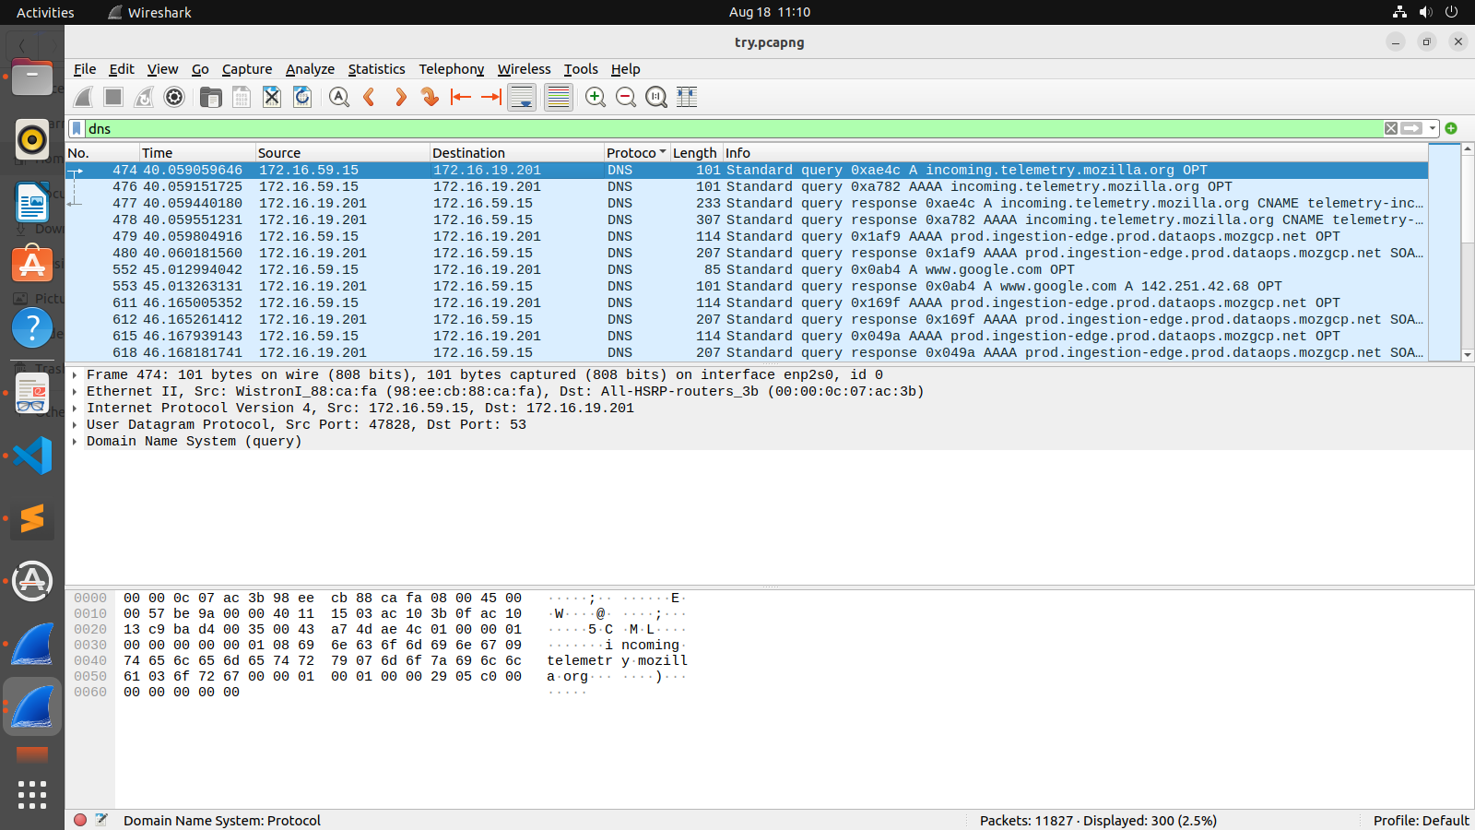

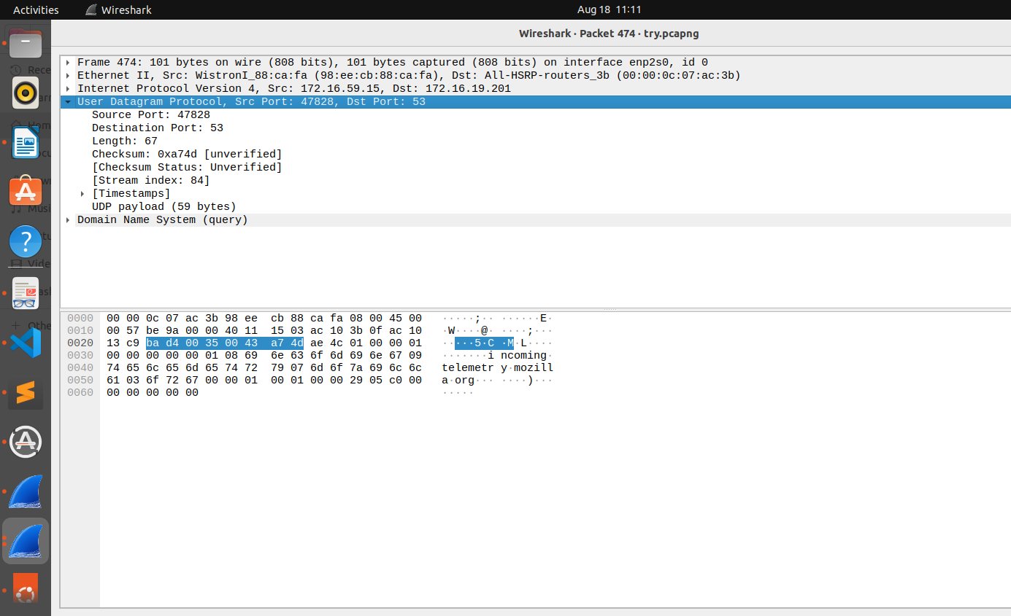

2a. Analyzing UDP datagrams using Wireshark:
• Start your web browser and clear the browser's cache memory, but do not access any
website yet.
• Open Wireshark and start capturing.
• Go back to your web browser and retrieve any file from a website. Wireshark starts
capturing packets.
• After enough packets have been captured, stop Wireshark, and save the captured file.
• Using the captured file, analyze TCP & UDP packets captured
.Note: DNS uses UDP for name resolution & HTTP uses TCP
Using the captured information, answer the following questions in your lab report.

A. In the packet list pane, select the first DNS packet. In the packet detail pane, select the
User Datagram Protocol. The UDP hexdump will be highlighted in the packet byte lane.
Using the hexdump, Answer the following:

a. the source port number
=> 47828 (The source port number is the first four hexadecimal digits)
b. the destination port number
=> 53 (The destination port number is the second four hexadecimal digits)
c. the total length of the user datagram
=> 67 bytes (The third four hexadecimal digits define the length of the whole UDP packet)
d. the length of the data:
=> 67-8 = 59 bytes (The length of the data is the length of the whole packet minus the length of the header)
e. whether the packet is directed from a client to a server or vice versa
=> Client to Server (Since the destination port number is 53 (well-known port))
f. the application-layer protocol:
=> UDP
g. whether a checksum is calculated for this packet or not:
=> Yes, 0xa74d [unverified]

B. What are the source and destination IP addresses in the DNS query message? What are those addresses in the response message? What is the relationship between the two?
=> Source: 172.16.59.15, Destination: 172.16.19.201
In a DNS query message, the source IP address is the IP address of the device sending the query, and the destination IP address is the IP address of the DNS server being queried.

Source:172.16.19.201 , Destination:172.16.59.15
In the DNS response message, the source IP address is the IP address of the DNS server that is sending the response, and the destination IP address is the IP address of the device that initiated the query.
The DNS query message is initiated by the device seeking information from a DNS server, and the DNS response message is sent back from the DNS server containing the requested information.

C. What are the source and destination port numbers in the query message? What are those
addresses in the response message? What is the relationship between the two? Which port
number is a well-known port number?
=> In the query message, the source port number is 47828 and the destination port number is 53.
In the response message, the source port number is 53 and the destination port number is 47828.
The source port number in the query message becomes the destination port number in the response message, and vice versa. Query is sent from Client to Server where as Response is sent from Server to Client.
The well-known port number in this case is 53, which is the port number reserved for DNS (Domain Name System) services.

D. What is the length of the first packet? How many bytes of payload are carried by the first
packet?
=> Length of the first packet: 67 bytes, Payload: 59 bytes

------------------------------------------------------------------------------------------------------------------------
------------------------------------------------------------------------------------------------------------------------

2b. Analyzing TCP packets using Wireshark:
Start your web browser and clear the browser's cache memory, but do not access any website yet.
■ Open Wireshark and start capturing.
■ Go back to your web browser and retrieve any file from a website. Wireshark starts capturing
packets.
■ After enough packets have been captured, stop Wireshark and save the captured file.
■ Using the captured file, select only those packets that use the service of TCP. For this purpose,
type tcp (lowercase) in the filter field and press Apply. The packet list pane of the Wireshark
window should now display a bunch of packets.

Part I: Connection-Establishment Phase
Identify the TCP packets used for connection establishment. Note that the last packet used for
connection establish may have the application-layer as the source protocol.

(
2 bytes: source port
2 bytes: destination address
4 bytes: sequence number
4 bytes: acknowledgement number
4 bits: HLEN 5 -- this indicates number of sets of 4 bytes which makes the header lenght = 20bytes..
6 bits: reserved
6 bits: control bits
2 bytes: window length
2 bytes: Checksum
2 bytes: Urgent pointer
)
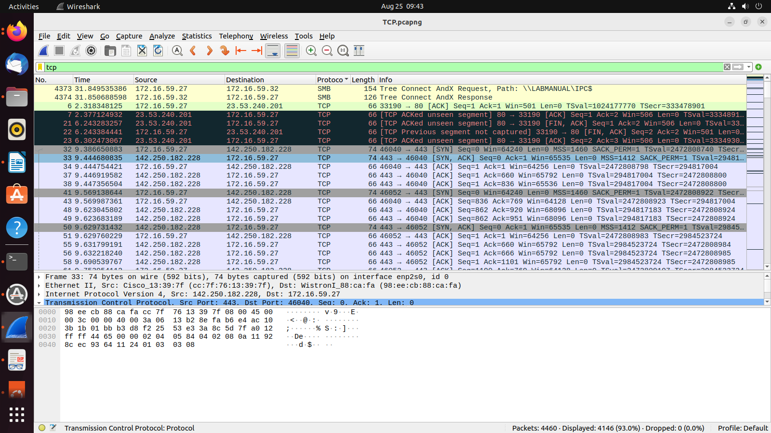
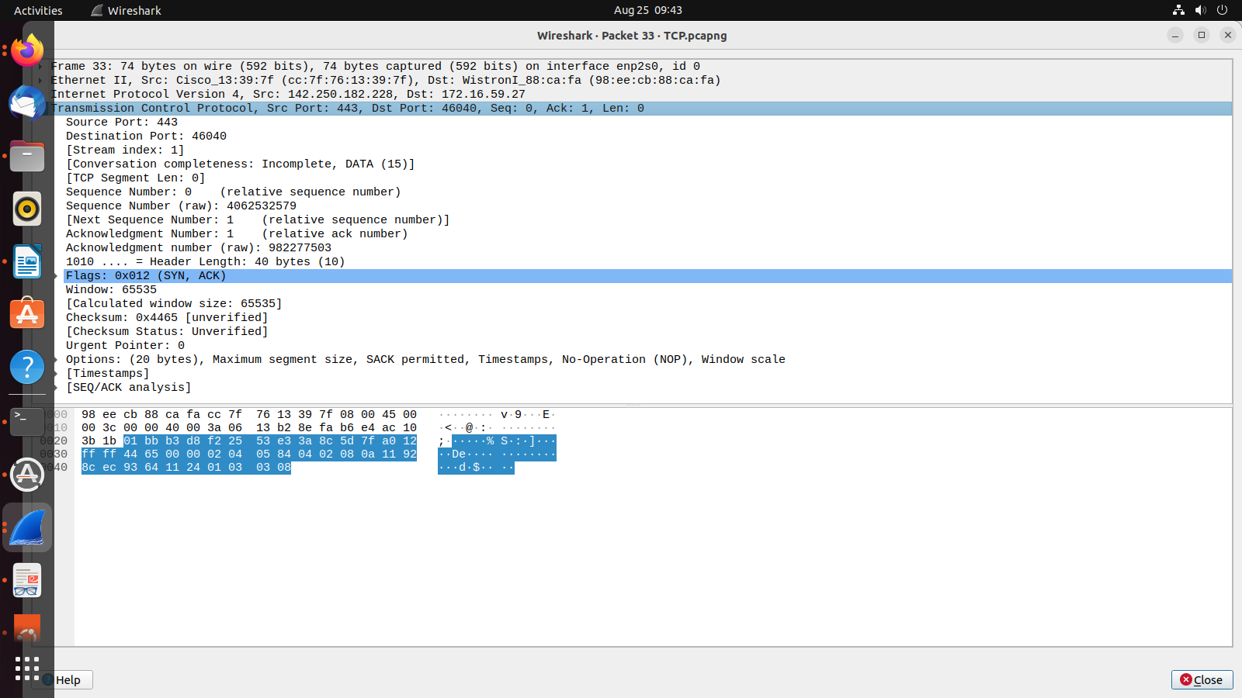

1. What are the socket addresses for each packet?
=>Socket Addresses: The socket addresses for each packet include the source and destination IP addresses, as well as the source and destination port numbers. For example:
- Host A's IP address: 142.250.182.228
- Host B's IP address: 172.16.59.27
- Host A's source port: 443
- Host B's destination port: 46040

2. What flags are set in each packet?
=> Flags (TCP packets have various flags that indicate the specific purpose or features of the packet) that can be seen:
- SYN (Synchronize): Initializes a connection.
- ACK (Acknowledgment): Acknowledges received packets.
Other common Flags:
- PSH (Push): Urges the receiver to deliver the data to the application.
- FIN (Finish): Terminates the connection.
The flags set in each packet can vary based on the specific purpose and stage of the TCP connection. The TCP handshake (establishment) involves SYN and ACK flags.

3. What are the sequence number and acknowledgment number of each packet?
=>In TCP, sequence numbers are used to keep track of each byte of data sent, while acknowledgment numbers confirm the receipt of data. These numbers are essential for managing reliable data transmission.
The sequence number(4062532579) represents the byte number of the first byte in the segment's data. The acknowledgment number(982277503) indicates the next expected byte from the other side.

4. What are the window size of each packet?
=>The TCP window size(65535, here) refers to the amount of data (in bytes) that the sender is allowed to transmit without receiving an acknowledgment from the receiver. It is a flow control mechanism that prevents overwhelming the receiver.

------------------------------------------------------------------------------------------------------------------------

Part II: Data-Transfer Phase
The data-transfer phase starts with an HTTP GET request message and ends with an HTTP OK
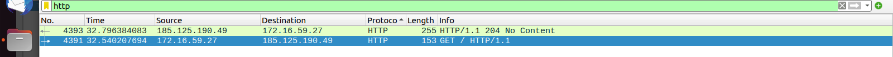
message.
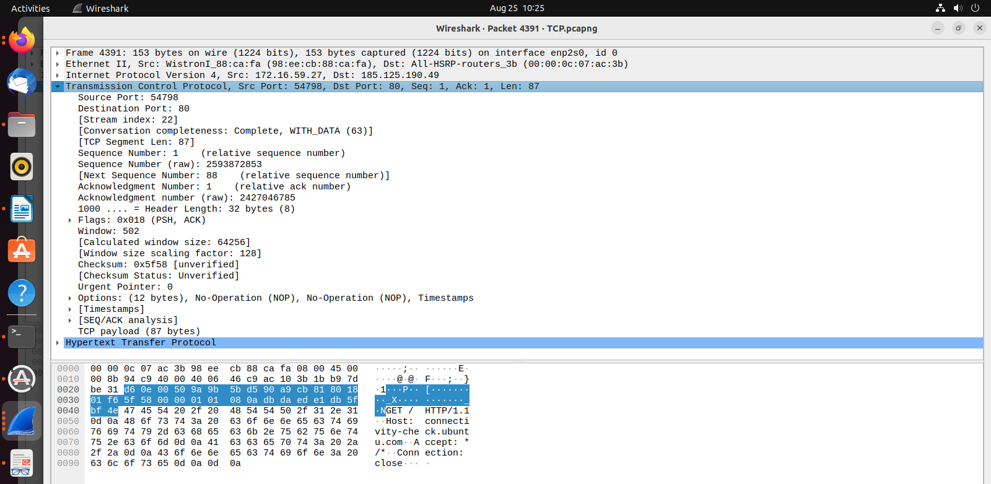
//2-7 check
1. What TCP flags are set in the first data-transfer packet (HTTP GET message)?
=> 0x018 (PSH, ACK)

2. How many bytes are transmitted in this packet?
=> 87 (payload)+ 32 (header) = 119

3. How often does the receiver generate an acknowledgment? To which acknowledgment rule
(defined in Page 200 in the textbook) does your answer correspond to?
=> The frequency at which acknowledgments are generated depends on the specific implementation of TCP and the network conditions. Selective Acknowledgment (SACK): Some TCP implementations support a feature called Selective Acknowledgment (SACK), which allows the receiver to acknowledge the receipt of non-contiguous segments. This can be particularly useful in situations where segments arrive out of order due to network congestion or other issues. SACK can result in more ACKs being generated when compared to traditional cumulative ACKs.

Highest Acknowledged Sequence Number = Acknowledgment Number - 1 = 2427046785 - 1 = 2427046784
Now, let's consider the cumulative acknowledgment rule:
If the acknowledgment number is equal to the highest sequence number being acknowledged, then it's a cumulative acknowledgment.
In this case, the highest sequence number being acknowledged is 2427046784. If the acknowledgment number is also 2427046784, then it's a cumulative acknowledgment.
However, the provided acknowledgment number (2427046785) is greater than the highest sequence number being acknowledged (2427046784). This suggests that selective acknowledgment (SACK) might be in use.
Selective Acknowledgment (SACK) allows the receiver to acknowledge non-contiguous ranges of data. It's likely that the receiver is acknowledging data up to the sequence number 2427046784 and indicating through SACK options which segments it has received out of order or that need to be retransmitted.
To definitively determine the type of acknowledgment rule and the SACK information being used, it would be helpful to analyze the packet's options field to see if SACK options are present and to check if there are any additional ACK packets that might provide more context.

4. How many bytes are transmitted in each packet? How are the sequence and acknowledgment numbers related to number of bytes transmitted?
=> Total Packet Size = Ethernet Header Size + IP Header Size + TCP/UDP Header Size + Payload Size

5. What are the original window sizes that are set by the client and the server? Are these numbers expected? How do they change as more segments are received by the client?
=> TCP sequence and acknowledgment numbers ensure reliable data transmission by tracking the order and receipt of bytes within a stream. These numbers are used to manage TCP segments, each of which carries a portion of an HTTP message. The number of bytes transmitted in a TCP segment isn't directly tied to the sequence/acknowledgment numbers; it's determined by factors like the payload size and network conditions. The sequence and acknowledgment numbers ensure that these segments are correctly ordered and received, guaranteeing the integrity of the entire HTTP message.

6. Explain how the window size is used in flow control?
=> The window size in flow control determines how much data the sender can send without receiving an acknowledgment from the receiver. The sender should not send more data than the receiver can handle (indicated by the window size) to avoid overwhelming the receiver. The window size is used to regulate the rate of data transmission and prevent congestion on the network.

7. What is the purpose of the HTTP OK message in the data transfer phase?
=> The purpose of the HTTP OK message in the data transfer phase is to indicate that the requested resource was successfully received, understood, and accepted by the server. It is a positive response from the server, confirming that the client's request was valid and the server is responding with the requested content. The OK message is part of the HTTP status codes, and in this case, it signifies a successful transfer of data.

------------------------------------------------------------------------------------------------------------------------

Part III: Connection Termination Phase
The data-transfer phase is followed by the connection termination phase. Note that some packets
used in the connection-termination phase may have the source or sink protocol at the application
layer. Find the packets used for connection termination.

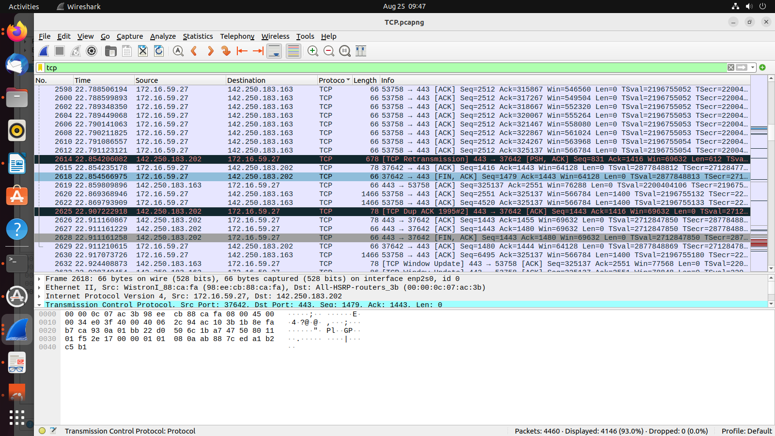

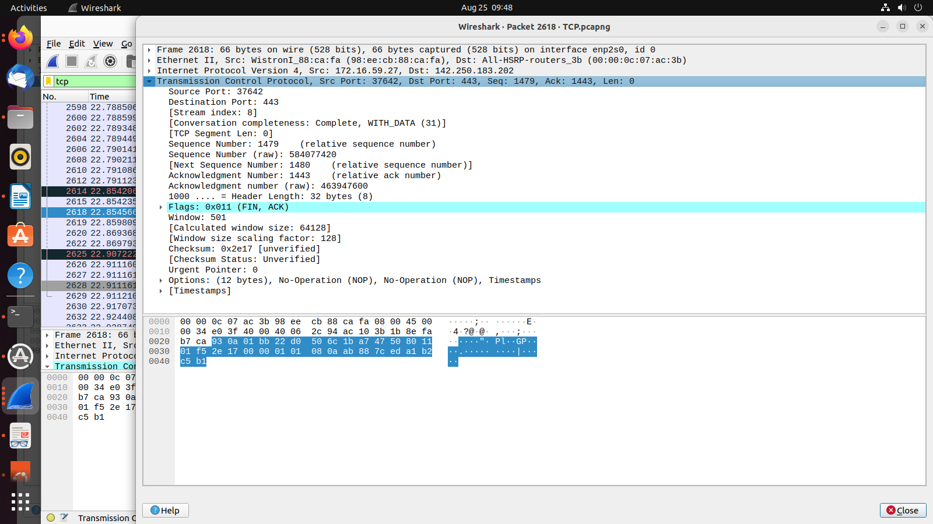
1. How many TCP segments are exchanged for this phase?
=> Four segments (packets) are exchanged to gracefully close the connection. This process is known as the "TCP Four-Way Handshake". Client Initiated Termination, Server Acknowledgment of Client's FIN, Server Initiated Termination, Client Acknowledgment of Server's FIN.
(37642->443, 443->37642)

2. Which end point started the connection termination phase?
=> The Client (port 37642) initiated the connection termination phase

3. What flags are set in each of segments used for connection termination?
=> The flags set in each segment used for connection termination in TCP:
-Client Initiated Termination (FIN Segment) -> FIN
-Server Acknowledgment of Client's FIN (ACK Segment) -> ACK
-Server Initiated Termination (Optional FIN Segment) -> FIN
-Server's ACKnowledgment of Its Own FIN (ACK Segment) -> ACK
-Client's ACKnowledgment of Server's FIN (ACK Segment) -> ACK
The primary flags used in connection termination are FIN (Finish) and ACK (Acknowledgment), depending on the action being taken by each endpoint. The specific flags set depend on the direction and timing of termination initiated by the client and server.
//check 3

------------------------------------------------------------------------------------------------------------------------

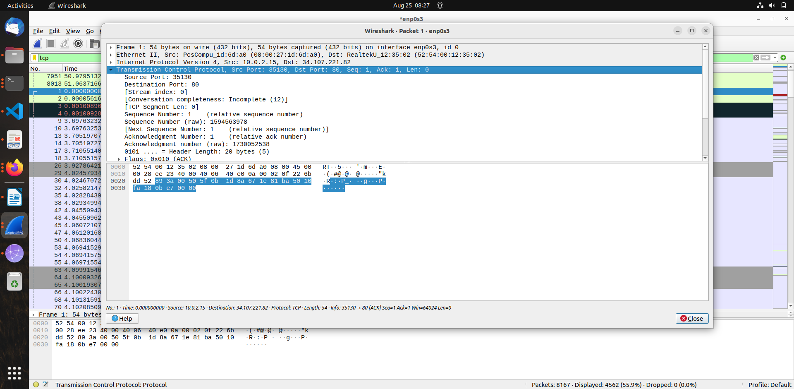

II. LAB EXERCISES:

1. From the captured information, answer the following:

i. Using the hexdump, determine the following for any TCP packet:
=>
Source port number- 443 (0x01bb)
Destination port number- 46040 (0xb3d8)
Sequence number: 4062532579 (0xf22553e3),
Acknowledgment number: 982277503 (0x3a8c5d7f),
Header length: 40 bytes (0xa)
Set flags: SYN, ACK (0x012)
Window size: 65535 (0xffff)
Urgent pointer value: 0

ii. Using the information in the detail pane lane, verify your answers is question 1.
=> Verified

iii. Does any of the TCP packet header carry options? Explain your answer.
=> The captured packet header carries options. TCP options are typically seen as a list of bytes, each representing a specific option type and its associated data. The TCP hex dump (after the urgent pointer bytes): 02 04 05 84 04 02 08 0a 11 92 8c ec 93 64 11 24 01 03 03 08

- Option 1: Maximum Segment Size (MSS)
  - Option Kind: 0x02
  - Option Length: 0x04 (4 bytes)
  - Option Data: 05 84 (hexadecimal) -> 1444 (decimal)
The MSS option specifies the maximum segment size that the sender is willing to receive.
- Option 2: SACK Permitted
  - Option Kind: 0x04
  - Option Length: 0x02 (2 bytes)
The SACK Permitted option indicates that the sender is willing to receive Selective Acknowledgment (SACK) information.
- Option 3: Timestamps
  - Option Kind: 0x08
  - Option Length: 0x0a (10 bytes)
  - Option Data: 11 92 8c ec 93 64 11 24 (8-byte timestamp value)
The Timestamps option is used for tracking the time at which the sender's data was sent and received.
- Option 4: No-Operation (NOP)
  - Option Kind: 0x01
  - Option Length: N/A (NOP doesn't have a length field)
No-Operation (NOP) options are used to pad the TCP options if needed.
- Option 5: Window Scale
  - Option Kind: 0x03
  - Option Length: 0x03 (3 bytes)
  - Option Data: 08 (hexadecimal)
The Window Scale option specifies a scaling factor to extend the window size beyond the 16-bit limit.
Some TCP options have variable lengths, and the interpretation of option data might require additional context.

iv. What is the size of a TCP packet with no options. What is the size of a TCP packet
with options?
=> A TCP packet with no options consists of the TCP header and the data payload. The TCP header has a fixed size of 20 bytes, and the data payload size can vary depending on the application data being sent. Therefore, it is: (20 + Data Payload)

The size of a TCP packet with options can vary based on the specific options included in the TCP header. Each option has its own length, and the total size of the TCP packet will depend on the sum of the TCP header size, the combined size of the options, and the size of the data payload. A standard TCP header is 20 bytes in size. The Data Offset field in the TCP header indicates the length of the TCP header including options. This field is expressed in 32-bit words, so it needs to be multiplied by 4 to get the size in bytes. Therefore, it is: (20 + Sum of Option Sizes + Data Payload)

v. Is window size in any of the TCP packet zero? Explain your answer.
=> //apply filter tcp.window_size == 0
A window size of 0 means that the receiver's buffer for incoming data is full, and the sender should stop sending more data until the receiver's buffer has space available. This helps prevent congestion and ensures that data is processed effectively on the receiving end before more data is sent.

2. Analyze Interaction between your TCP Client-Server Programs using wireshark
3. Analyze Interaction between your UDP Client-Server Programs using wireshark

